Hoa Loi Primary School

Student’s name:…………………………………………

Class: ……..

**ĐỀ ÔN TIẾNG ANH LỚP 3**

**1.** **Write** **and** **match.**

**1.** i k e t kite

**2.** o l d l ____

**3.** n t r i a _____

**4.** d t e d y r a e b ______

**5.** i k e b ______

**2.** **Order** **the** **words.**

a. This / bike. / is / my

**-** This is my bike.

b. it / Yes, / is.

* …………………………………………….

c. my / This / kite. / Is

- ………………………………………….

d.your / Is / this / train?

- ………………………………………………………..

**e.** isn’t. / it / No,

- ……………………………………………………….

f.this / your / bag? / Is

- …………………………………………..

**3.** **Complete** **the** **answers.**

**1**.Is this your teddy bear? Yes, it is .

**2.** Is this your doll? No, it .

**3.** Is this your hat? No, .

**4**.Is this your train? Yes, .

**4.Look** **and** **write:** **Yes, it is. No, it isn’t.**



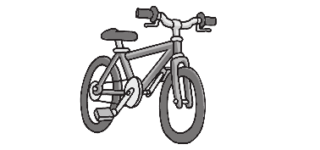

**1.** Is this your bike ? Yes, it is.

 **2.** Is this you ?

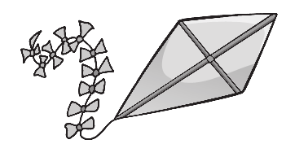



**3.** Is this your ?

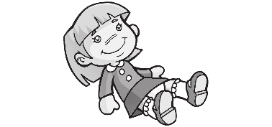



**4.** Is this your ?

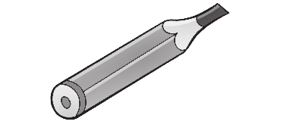



**5.** Is this your ?



**5. Write.** This is These are



1. These are my eyes

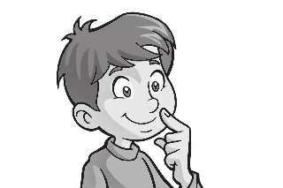

1. _________ my nose

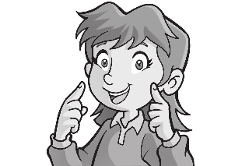

3. _________ my face

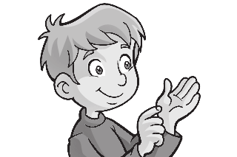

4. _________ my hands