UNIT 1: CLEAN UP
- Look and match
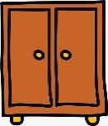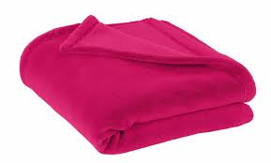
cabinet
blanket
rug
pillow
shelf

- Look and write Yes , it is or No , it isn’t.

 | 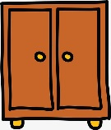
Is it a blanket ?................................... | Is it a cabinet ?...................................
Is it a rug ?.......................................... | Is it a shelf ?.......................................
- Read and circle.
- There is /are ten books on the shelf.
- There is /are a doll on the bed.
- There is /are a ball under the chair.
- There is /are a teddy bear on the bed.
- There is /are a pencil case in the bag.
- There is /are two robots in the box.

IV.Make questions

a) How many apples are there on the table ?
There are three apples on the table.
b) .................................................................................................
There is a cat under the chair.
c) .................................................................................................
There are ten books on the shelf.
d) .................................................................................................
There is a pillow on the bed.
e) .................................................................................................
There are two dolls on the rug.
f) .................................................................................................
There are four books in the bag.
.....................................................................................................

UNIT 2: OUR NEW THINGS
I.Fill in the blanks
a. That is a ______________________. 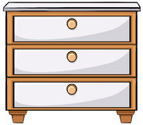

b. This is a ___________________.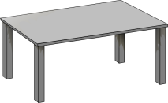
3.That is a ___________________ .
4.These are ___________________.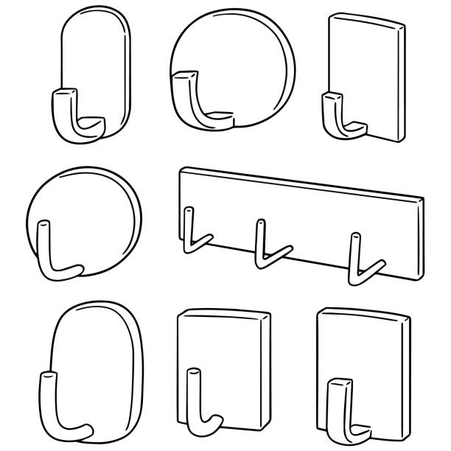
II.Answer the question
1.What is that ? ( a pencil case) ______________________________________________
2.What are those ?(books) ____________________________________________________
3. What is this ? ( a table ) ___________________________________________________
4.What are these ? ( coat hooks ) ___________________________________________________
5.What is this ( a picture) ____________________________________________________
6.What are these ?( computers) ______________________________________________
III. Make a question and an answer for every number.
1) What’s _____________? ________________________. 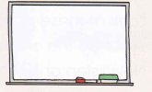
2)________________________? _____________________.
3)________________________? ______________________.
4) ________________________?____________________.
IV. Reorder the words to make the correct sentences.
a)bike. /my/ That/is/_________________________________________.
b) school. / That /my /is/_________________________________________.
c) Those / are /pens./my/_________________________________________.
d) are /These / computers./_________________________________________.
e) coat hooks./Those/are/_________________________________________.
f) picture ./ This /a /is/_________________________________________.
g). Those/ tables./ are. _________________________________________.
UNIT 3:DO YOU HAVE A MILKSHAKE?
I. Complete with have or has
a. I ________ chicken. 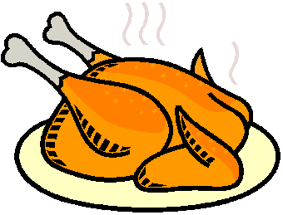 b. She _________ an apple.
c. She _________ a pizza. 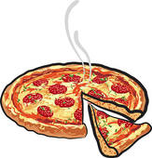 d. He __________ a milkshake.
e.I ________ a sandwich. 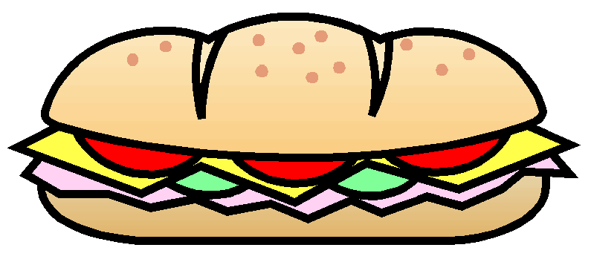 f. They ____________ grapes.
II. Reorder the words to make the correct sentences.
a. /an /orange./ He /has /__________________________________.
b. have /We/ a /pizza./ _________________________________.
c. They /have / sweets./ _______________________________.
d. Does/ have/ she / salad ?/ __________________________________?
e. Lily / an /orange./ has / ______________________________.
f. they/ Do/ have/ biscuits?/ ____________________________________?
III.Circle the correct option.
a. Does Jerry have a pizza ? No , he does/ he doesn’t.
b. Do Mary and Jack have chicken ? No , they do /they don’t .
c. Do Mary and Jack have fries ? Yes , they do /they don’t .
d. Does Jerry have a banana ? No , he does /he doesn’t .
e. Does Mary and Jack have salad ? Yes , they do /they don’t .
f. Does Jerry have a sandwich ? No , he does /he doesn’t .
IV. Look , read and put a tick () or cross (

I have a milkshake . | He has salad.
She have a milkshake. | Peter has chicken.

UNIT 4: WE HAVE ENGLISH
- Write the missing letters
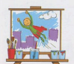 | 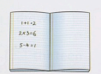 | 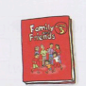 | 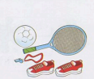
a _ _ | _ _ th | e _ _ lish | _ _

- Write.
a. What do you have on Monday?  _________________________. (English and Math) | b. What does he have on Tuesday?  ___________________________. (Math and P.E.)
c. What do you we on Monday?  _________________________. (Music and Math) | d. _______________________________________?  We have English and Math on Friday.
- Reorder the words to make the correct sentences.

a. Do /have/you/ English /on /Wednesday?  Yes , I do. | b. Peter / and / Tony// Math/have /on /Friday.
………………………………………………………… | …………………………………………………………
c. have / music/ We /Monday. /on/ | d. Does/ she/ Music /have/ on / Thursday ?  Yes , she does.
………………………………………………………… | …………………………………………………………

- Write about you.
My favorite subject is ______________________________.
I have _______________________________on Monday and Friday.
I have ______________________________ on Tuesday and Thursday.
I don’t have __________________________ on Wednesday.
The most difficult subject is ______________________.

UNIT 5: LET’S BUY PRESENTS!

1.Look at the pictures and write.
1.balloons 2. card
3.cake 4. candles
5.hat 6. present
7.ice-cream 8. friends
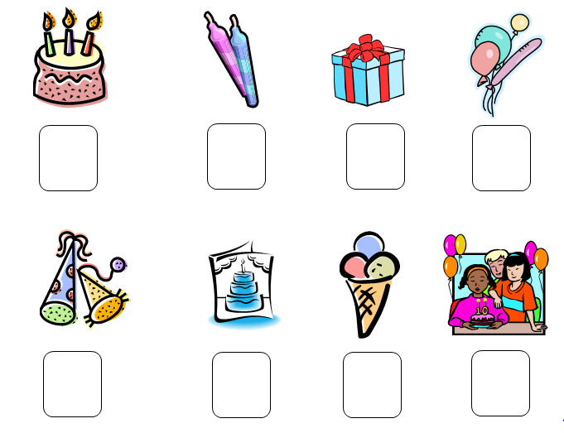
II. Write like , likes , don’t like or doesn’t like.
Lisa _____________ card. | 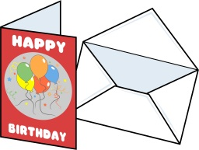
He _____________ balloons.
I ____________ cake. | 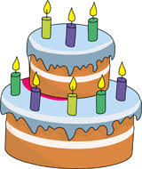
She ________ nuts | 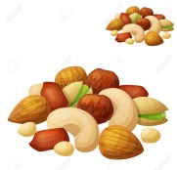
III. Fill in the blanks with do or does.

a. What ______ you like ?  I like balloons. | b. What _______ she like ?  She likes cake.
c .___________ you like presents ?  Yes , I do . | d.___________ she like candy ?  No , she doesn’t.
e. What ________ he like ?  He likes card. | f. What _________ they like ?  They like candy.
IV. Reorder the words to make the correct sentences.
a. you/ Do /like / candy ?/
______________________________________?
b.What /like ?/does /she /
______________________________________?
c. Does /like/she /chocolate ?/
______________________________________?
d. She/ presents ./likes/
______________________________________.
e. like / balloons./I
UNIT 6: WHAT TIME IS IT ?
- Read and draw.
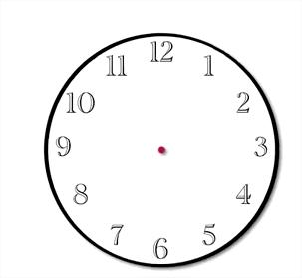

It’s one o’clock. | It’s two o’clock. | It’s three o’clock  .
It’s four o’clock. | It’s five o’clock. | It’s six o’clock.

II.Write
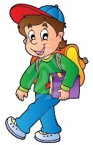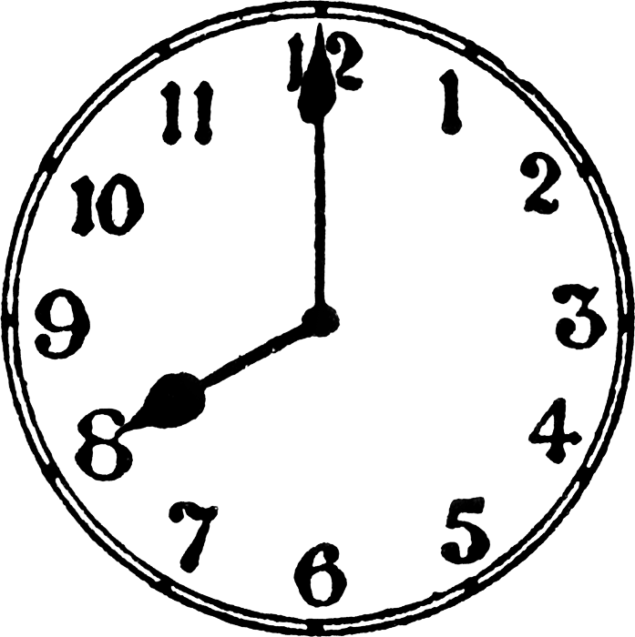  He ______________________________ | 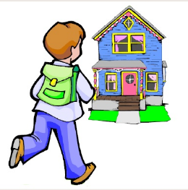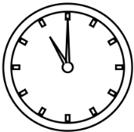  He ________________________________
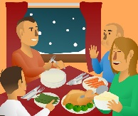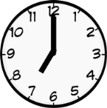  He __________________________ | 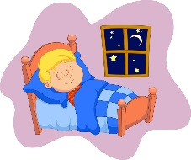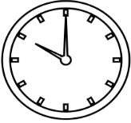  He ______________________________
III. Fill in the blanks.
1. She goes to school in the _______________ 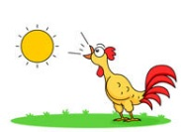
2. He plays soccer ______________________ 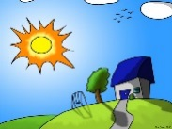
3. She has dinner ______________________ 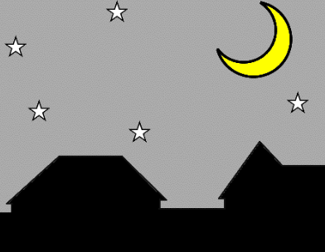
4. He goes to bed ________________________
IV.Circle
a. I don’t / doesn’t get up at six o’clock.
b. He don’t /doesn’t swim in the evening.
c. We don’t /doesn’t go to school in the summer.
d. The shop don’t /doesn’t open at six o’clock in the morning.

UNIT 7 WHERE DOES SHE WORK ?
1.Look And Write
 | 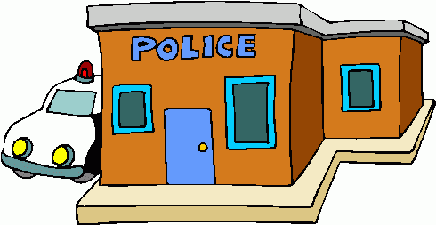
……………………………….. | ……………………………….. | ………………………………..
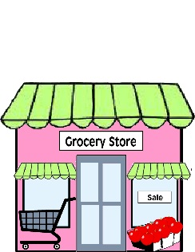 | 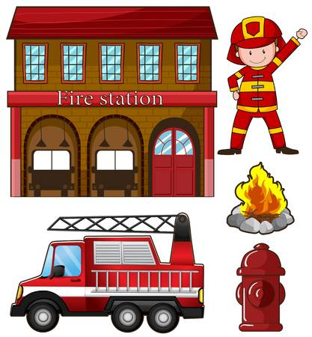 | 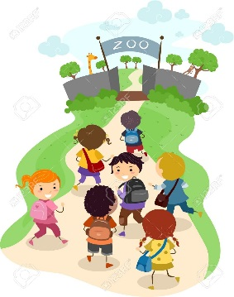
……………………………….. | ……………………………….. | ………………………………..
2.Look and answer .
 | Where does he work ? | ………………………………
 | Where does he work ? | ………………………………
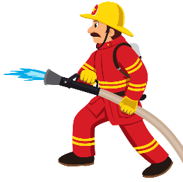 | Where does he work ? | ………………………………
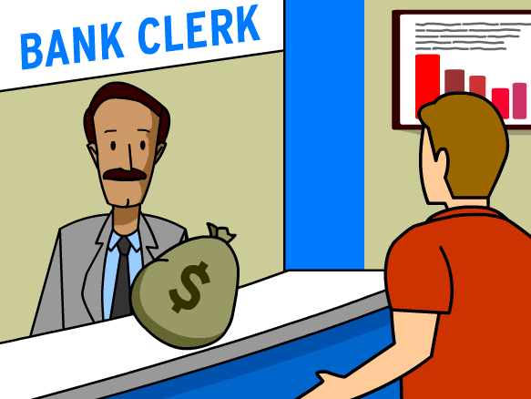 | Where does he work ? | ………………………………
3. Fill in the jobs.
1.…………………………… works in a hospital.
2. ………………………………… works in a school.
3. ………………………………… works in a police station.
4.………………………………… works in a fire station.
UNIT 8: IT’S HOT TODAY !
I. Match
1.It’s cold. | a .Don’t put on your coat.
2.It’s windy. | b. Fly a kite .
3.It’s hot . | c. Make a snowman.
4.It’s raining. | d. Don’t forget your umbrella.
5.It’s snowing. | e. put on a sun hat.
6.It’s sunny. | f. put on a coat.
II.Look , read and tick () or cross (×)
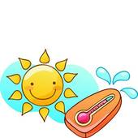
It's hot.
It's windy.
It's sunny.
It's snowing.
It's windy .
It's raining .

