DE CUONG ON TAP MON TIENG ANH KHOI 2

I.Write ( viết ) 2m
mommy, swing, daddy, soup, run, slide
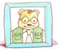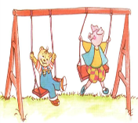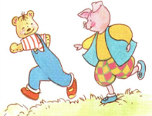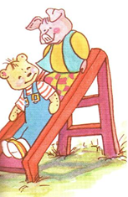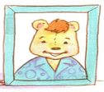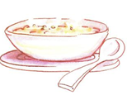
_______ ________ ________ ________ ______ _______
II.Check (đánh dấu vào ô đúng) 2m
1. sky 5. 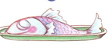 bread 9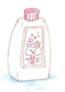towel
moon fish shampoo
2. 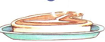 meat 6. soup 10.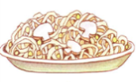 noodles
noodles rice soup
3 sky 7.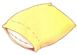 pillow 11.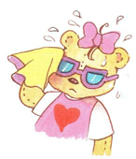 I’m wet
stars towel I’m hot
4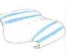towel 8. bear 12.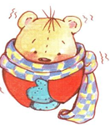 I’m cold
pillow blanket I’m wet
III.Complete the conversation (hoàn tất bài hội thoại sau) 2m
1.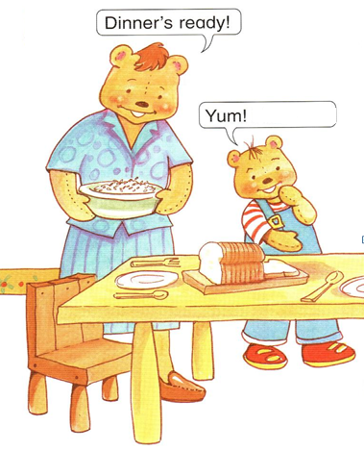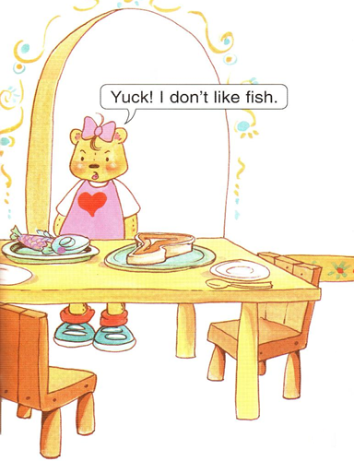
A.Yum ! I like fish
B. Yum ! I like meat
C. Yum ! I like bread
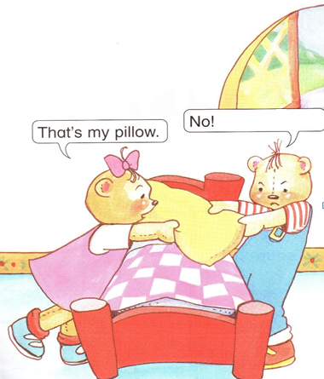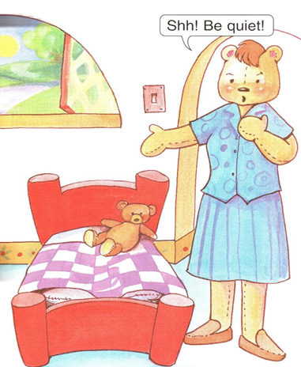
2. A.It’s my bear
B.It’s my blanket
C.It’s my pillow

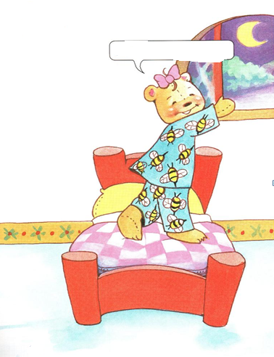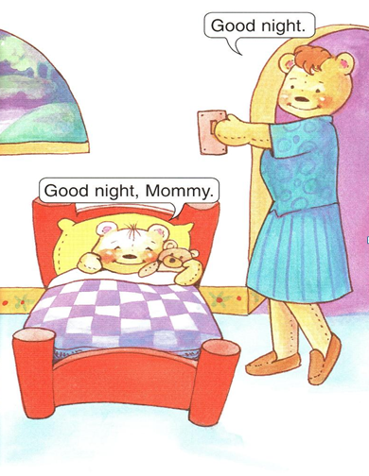
3.A.Look at the sky
B.Look at the stars
C.Look at the moon
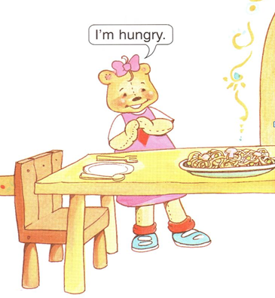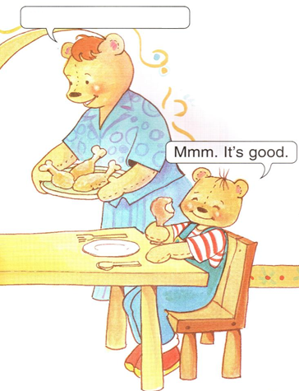
4. A.Have some noodles
B.Have some chicken
C.Have some soup
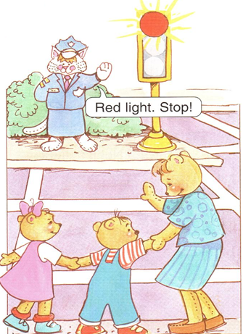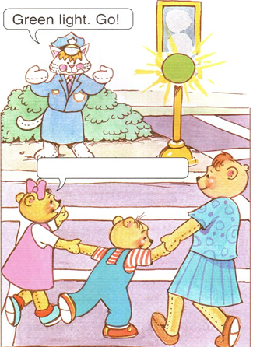
5. A.She’s a police officer
B.She’s a farmer
C.She’s a doctor
6.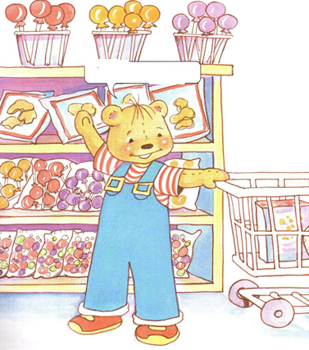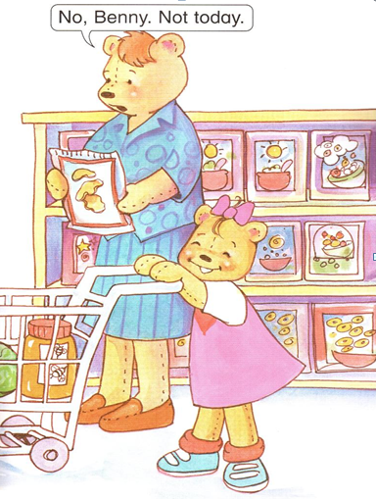
A.I want ice-cream
B.I want chips
C.I want candy
7.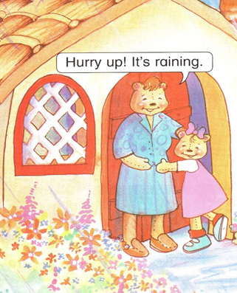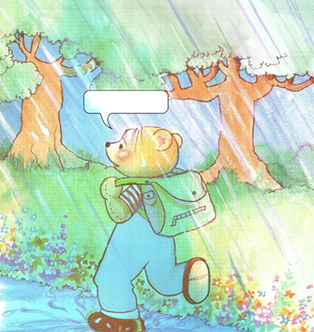
A. I’m hot
B.I’m wet
C.I’m cold
IV Match ( nối các câu sau ) 2m
1. police officer 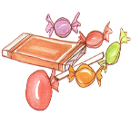
2.ice-cream 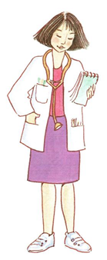
3. doctor 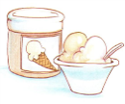
4.candy 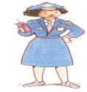
5. bear 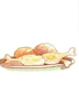
6. chicken 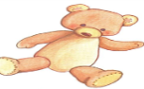
I.Write ( viết ) 2m
I’m hot
It’s sunny
I’m wet
It’s raining
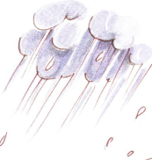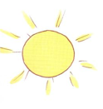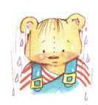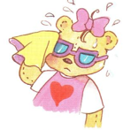
________ _________ _______ _________
II.Circle the correct picture (khoanh tron buc tranh dung) 2m:
1.I’m hot 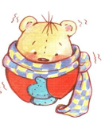
2. It’s sunny
3.I’m cold
4. I’m wet

IIIMatch (nối các câu sau ) 2m
1.I’m hot
2. It’s raining
3.I’m cold
4. I’m wet

IV.Check(đánh dấu vào ô đúng) 2m
1. I’m wet 3. It’s sunny
I’m cold It’s snowing
2. I’m wet 4. It’s sunny
I’m hot It’s raining
V.Complete the conversation (hoàn tất bài hội thoại sau) 2m

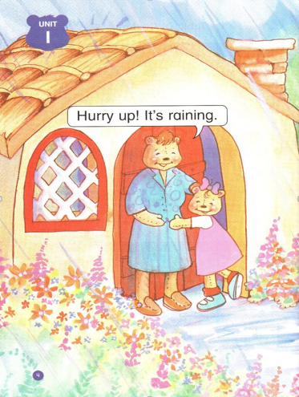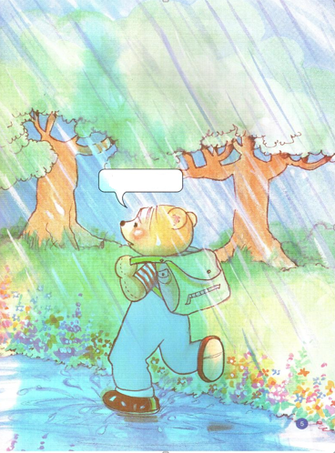
A.I’m hot
B.I’m wet
C.I’m cold

I.Write ( viết ) 2m
chicken
noodles
soup
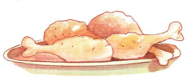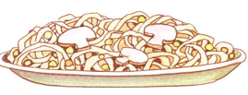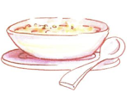
___________ _____________ _____________

II.Circle the correct picture (khoanh tron buc tranh dung) 2m:
1.Have some noodles 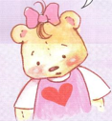
2. Have some chicken 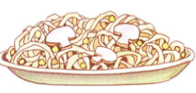
3.Have some soup 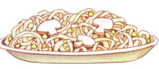
4.I’m hungry

IIIMatch (nối các câu sau ) 2m
1.chicken
2. noodles
3.soup
4. I’m hungry

IV.Check(đánh dấu vào ô đúng) 2m
1. I’m hungry 3. noodles
I’m cold chicken
2. 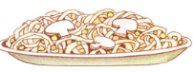 noodles 4. chicken
soup soup

V.Complete the conversation (hoàn tất bài hội thoại sau) 2m

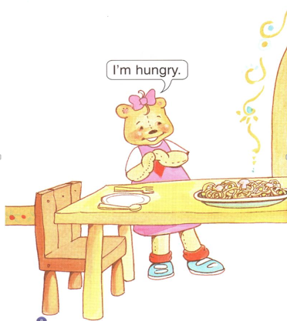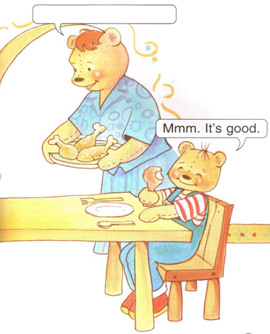
A.Have some soup
B.Have some chicken
C.Have some noodles

VI.Tìm và khoanh tròn các từ sau :

ACXSCHICKENNMKHSSOUPPUYTRENOODLESSDEWHUNGRYTRFDHAVESWSOME
1. 4.
2. 5.
3. 6.

VII.Reorder the sentences (Sắp xếp các câu sau) :
1.hungry / I / ‘m 4.have / soup / some
______________ __________________
2.some / have / chicken 5. good / ‘s / It
__________________ _________________
3.noodles / some / have 6.police officer / She’s / a
___________________ ____________________
7.farmer / a / He’s 8.She’s / doctor / She’s
__________________ _____________________

