Hoa Loi Primary School

Student’s name: ……………………… ; Class 2….

**ĐỀ ÔN TIẾNG ANH LỚP 2 ĐỀ 1 TỪ 16 – 20/3/2020**

**A.Write ( viết )**

|  |
| --- |
| Fish, rice, moon, sky |

 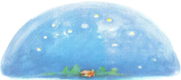  

________ _________ _______ _________

**B. READING.**

Part 1. Check : đánh dấu 🗸 vào ô đúng với hình

1.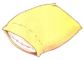 🗆pillow 2.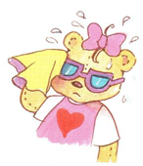 🗆I’m wet

🗆towel 🗆I’m hot

3.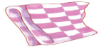 🗆chips 4.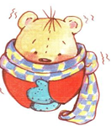 🗆I’m cold

🗆blanket 🗆I’m wet

Part 2. Match: nối (2 ms)

1.candy A. 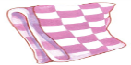

2.pillow B.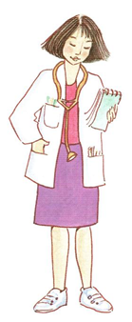

3.doctor C.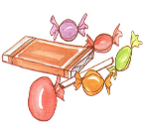

4.blanket D.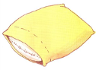

**1._____, 2.________, 3_______, 4_______.**

**C. WRITING.**

Part 1: Complete the dialogues with the words in the box ( Hoàn thành các bài hội thoại bên dưới, sử dụng từ trong khung )

noodles candy Stop chips pillow wet hungry

1. That’s my pillow.

No. It’s my _________.

2. I’m ________.

Have some chicken.

3. Red light. ________.

Green light. Go.

4. Hurry up ! It’s raining.

I’m ______.

Part 2: Reorder the following sentences: Sắp xếp câu

1. a / She’s / police officer. 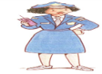 2.soup. / some / Have 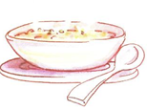

_____________________ __________________________

3. want / I / candy. 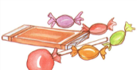 4. That’s / bear. / my 

 