|  |  |
| --- | --- |
| **Hoa Loi Primary School**  **Class: ………………**  **Name:………………………………………..** | **Review 6** |

**ĐỀ ÔN TIẾNG ANH LỚP 4 ( ĐỀ 2 TỪ 16 – 20/3/2020 )**

1. **Look and read. Write *yes* or *no*. There are two examples.**

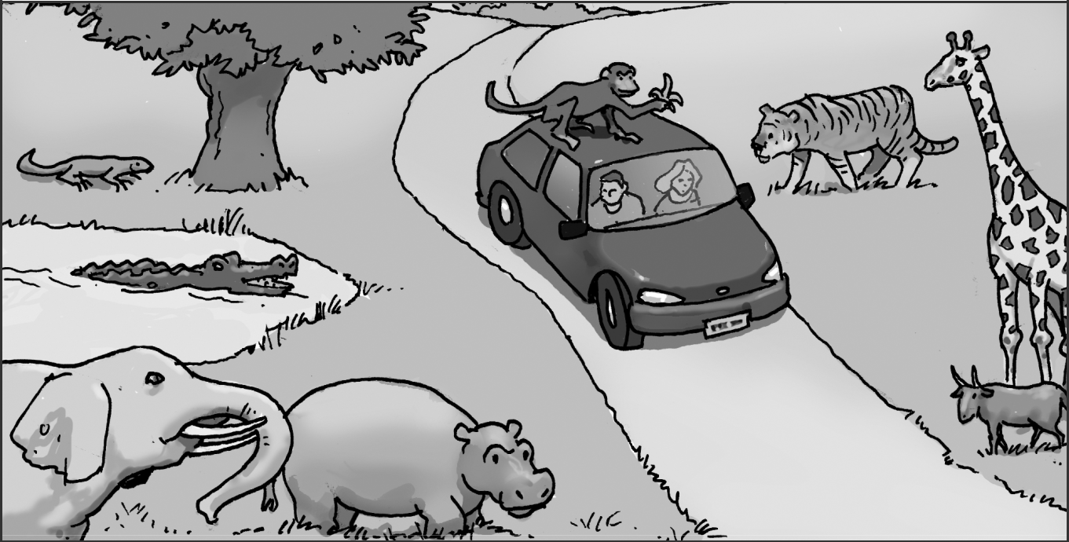

**Examples**

There is a crocodile in the water. ------YES--------

The monkey is next to the car. ------NO----------

**Questions**

1. The tiger is between the giraffe and the goat. -------------------------
2. There are two people in the car. -----------------------
3. There is a snake under the tree. -----------------------
4. The monkey has got a banana in its hand. ----------------------
5. The goat is in front of the giraffe. -----------------------

1. **Look and write.**

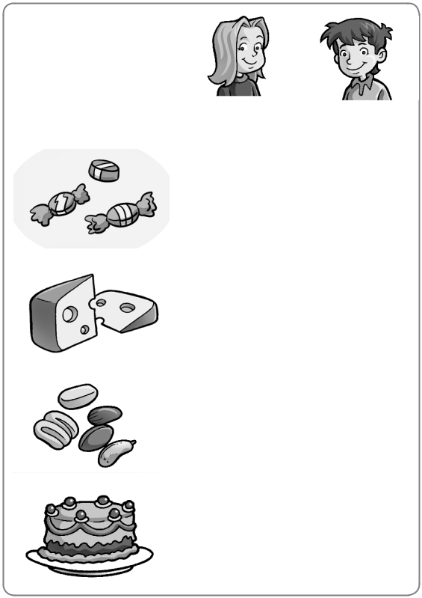

|  |  |  |  |  |  |  |  |  |  |  |  |  |  |  |
| --- | --- | --- | --- | --- | --- | --- | --- | --- | --- | --- | --- | --- | --- | --- |
|  |  |  | **1** | Celia | | |  | likes candy. | | | | | | |
|  |  |  |  |  |  |  |  |  |  |  |  |  |  |  |
|  | Celia | Max | **2** | She | |  | doesn’t like | | | | cheese. | | | |
|  |  | | |  |
|  | 3 | 3 | **3** | She | |  |  |  |  | nuts. | | | | |
|  |  |  |  |
|  |  |  | **4** |  |  |  |  |  |  |  |  |  |  |  |
|  | 7 | 3 |  |  |  |  |  |  |  |  |  |  |  |
|  | **5** | Max | | |  |  |  |  |  |  | candy. | |
|  |  |  | **6** | He |  | |  |  |  |  |  | cheese. | | |
|  | 3 | 7 |  |  |  |  |  |
|  | **7** | He | | | . | | | | | | | |
|  |  |  |
|  | 3 | 3 |
|  | **8** |  |  |  |  |  |  |  |  |  |  |  |
|  |  |  |  |  |  |  |  |  |  |  |  |  |  |  |

1. **Underline the correct word.**
2. What ( do / does / doesn’t) you like?
3. What does (I / they / he) like?
4. He (like / likes / don’t like) candy.
5. What (do / does / don’t) she like?
6. She (don’t / hasn’t / doesn’t) like nuts.
7. **Circle the odd-one-out. Write.**

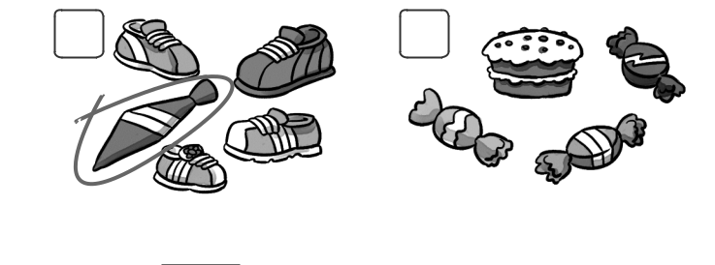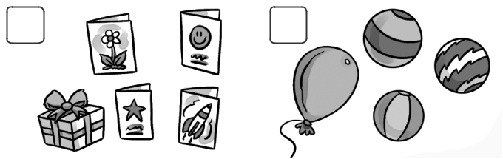

**1** **2** **3 4**

Tie _____________ _________ _____________