Hoa Loi Primary School
Student’s name: …………………………………….; Class:5…..
ĐỀ ÔN TIẾNG ANH LỚP 5 ( ĐỀ 2 TỪ 16 – 20/3/2020 )
1. Look , read and write
Yes, I am. | Yes, he is. | Yes, she is. | Yes, they are.
No, I’m not. | No, he isn’t. | No, she isn’t. | No, they aren’t.

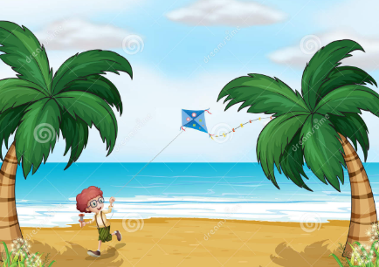 | 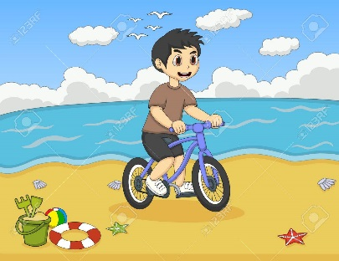 | 
Is he swimming ? | Is he sailing ? | Is he kayaking ?
……………………………….. | ……………………………….. | ………………………………..
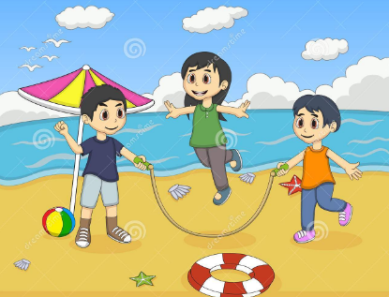 |  | 
Are they skipping ? | Are they swimming ? | Is he surfing ?
……………………………….. | ……………………………….. | ………………………………..
 | 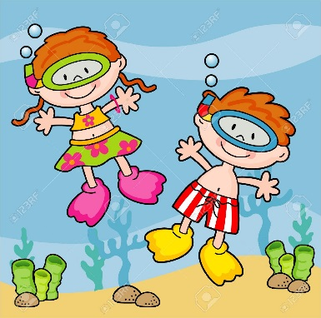 | 
Is he sailing ? | Are they snorkeling? | Are they flying kites ?
……………………………….. | ……………………………….. | ………………………………..

2.Put the words in the correct order to make sentences
 | 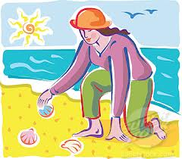 | 
are/They /taking /photos. | is/ She /collecting /sea shells. | are/They /flying/a kite.
…………………………………. | …………………………………. | ………………………………….
 |  | 
She/book./is/reading/a | They/swimming./are | kayaking./They/are
…………………………………. | …………………………………. | ………………………………….
 |  | 
snorkeling ./ She/is | surfing./She/is/ | She/making/is/a/sandcastle.
…………………………………. | …………………………………. | ………………………………….
 |  | 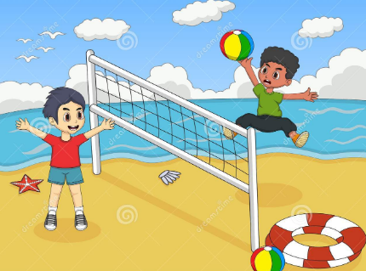
waterskiing./He/is | She/an/is/eating /ice cream. | are/They/playing/volleyball.
…………………………………. | ……………………………… | ………………………………….

