Hoa loi Primary School
Student’s name: ………………………………; Class: 5…….
ĐỀ ÔN TIẾNG ANH LỚP 5 ( ĐỀ 1 TỪ 16 – 20/3/2020 )
1.Look and write
swim beach kayak surf windsurf sail waterski snorkel

 |  | 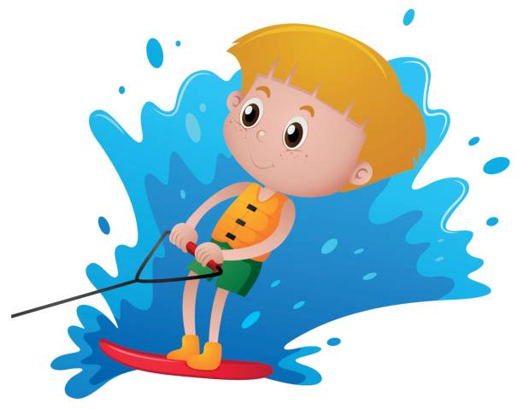 | 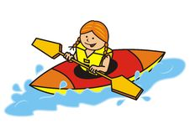
……………………. | ……………………. | ……………………. | …………………….
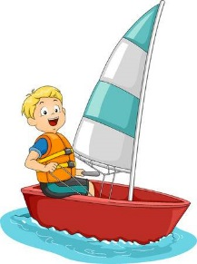 | 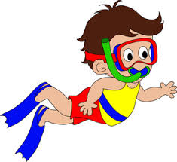 |  | 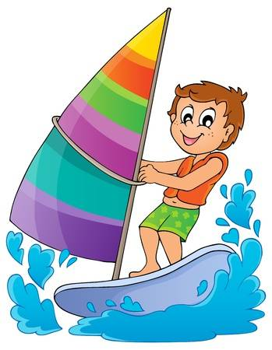
……………………. | ……………………. | ……………………. | …………………….

2. Read and number
 |  | 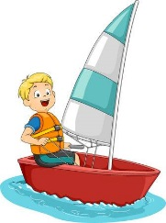

- He is surfing. | - He is waterskiing.
- She is kayaking. | - He is windsurfing.
- He is sailing. | - He is snorkeling.
3.Look and answer the questions
 | 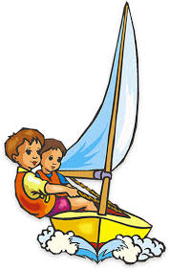 | 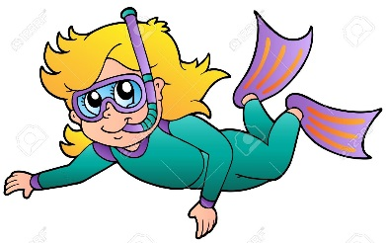
What are they doing ? | What are they doing ? | What is she doing ?
……………………………… | ……………………………… | ………………………………
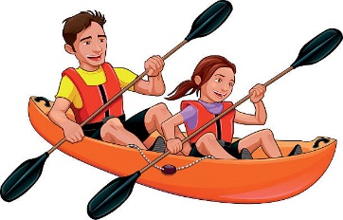 |  | 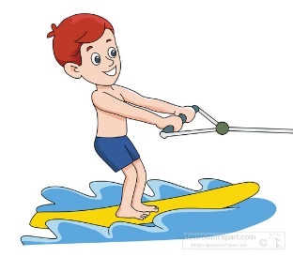
What are they doing ? | What is she doing ? | What is he doing ?
……………………………… | ……………………………… | ………………………………
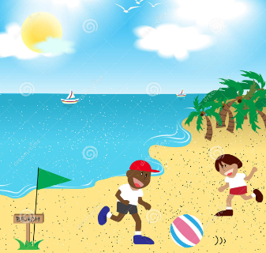 |  | 
What are they doing ? | What is she doing ? | What is he doing ?
……………………………… | ……………………………… | ………………………………
 | 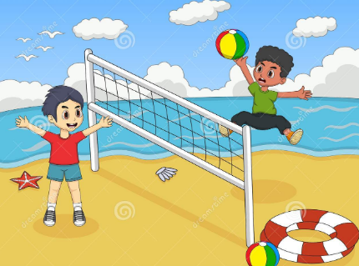 | 
What is he doing ? | What are they doing ? | What are they doing ?
……………………………… | ……………………………… | ………………………………

