|  |  |
| --- | --- |
| **Hoa Loi Primary School**  **Class: ………………**  **Name:………………………………………..** | **Review 5** |

**ĐỀ ÔN TIẾNG ANH LỚP 4 ( ĐỀ 1 TỪ 16 – 20/3/2020 )**

**I. Write. Correct the sentences.**

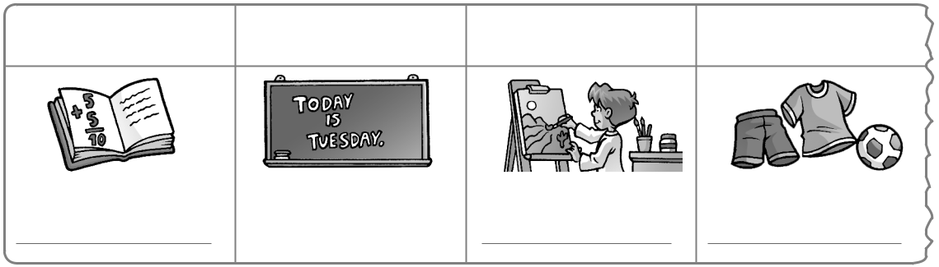

|  |  |  |  |
| --- | --- | --- | --- |
| Monday | Tuesday | Wednesday | Thursday |

English

1. We have P.E. on Tuesday.

No, we don’t. We have English on Tuesday.

1. We have English on Monday.

No, we don’t. on Monday.

1. We have P.E. on Wednesday.

No, we don’t. on .

1. We have math on Thursday.

No, we don’t. .

**II.Complete your schedule. Write.**

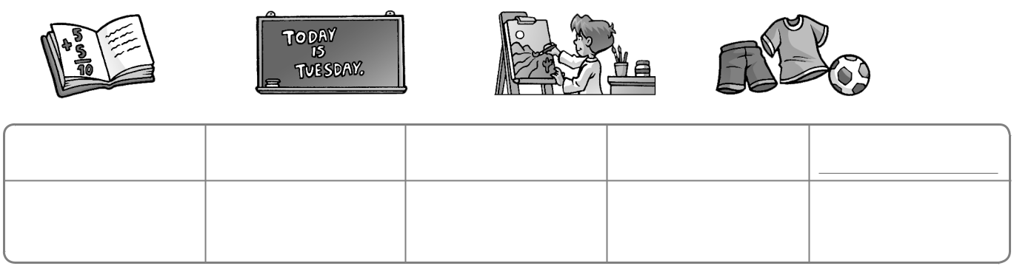

|  |  |  |  |
| --- | --- | --- | --- |
| Monday | Tuesday | Wednesday | Thursday |

|  |  |  |  |  |  |  |  |  |
| --- | --- | --- | --- | --- | --- | --- | --- | --- |
| **1** | We have | | |  |  |  | on Monday. | |
| **2** |  | We | |  |  |  |  | on Tuesday. |
| **3** |  |  |  |  |  |  |  |  |

**4**

**5**

|  |  |  |  |  |  |  |  |  |
| --- | --- | --- | --- | --- | --- | --- | --- | --- |
| **III. Match.** | |  |  |  |  |  |  |  |
| **1** | What do we |  | | **a** music. | | | |  |
| **2** | Today we have * | | | **b** have on Tuesday? | | | | | |
| **3** | When do we | * |  | **c** | P.E. today. | | |  |
| **4** | We have English* | | | **d** on Friday. | | | |  |
| **5** | What do* |  |  | **e** you have on Monday? | | | | | |
| **6** | I don’t* |  |  | **f** | have math? | | |  |
| **7** | We don’t have* | | | g have art today. | | | | |
|