Hoa Loi Primary School

Student’s name: ……………………… ; Class 2….

**ĐỀ ÔN TIẾNG ANH LỚP 2 ĐỀ 2 TỪ 16 – 20/3/2020**

**A.Write ( viết )**

|  |
| --- |
| daddy, sister, run, slide |

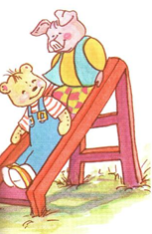 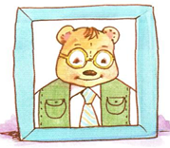 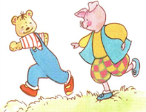 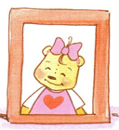

________ _________ _______ _________

**B. READING.**

Part 1. Check : đánh dấu 🗸 vào ô đúng với hình (2 ms)

1. 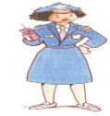🗆Police officer 3. 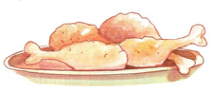🗆 chips

🗆doctor 🗆 chicken

2. 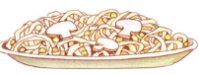🗆 noodles 4. 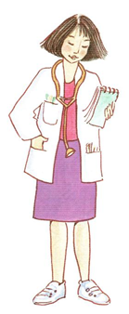 🗆 doctor

🗆 soup 🗆 farmer

**Part 2. Match: nối**

1. police officer A. 

2.ice-cream B 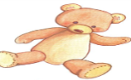

3. chicken C. 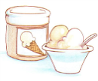

4.bear D. 

**1._____, 2.________, 3_______, 4_______.**

**C. WRITING.**

**Part 1: Complete the dialogues with the words in the box ( Hoàn thành các bài hội thoại bên dưới, sử dụng từ trong khung )**

noodles hot Green light bear pillow raining cold

1. That’s my bear.

No. It’s my _________.

2. I’m hungry.

Have some ________.

3. Red light. Stop.

___________. Go.

4. Hurry up ! It’s _________.

I’m wet.

**Part 2: Reorder the following sentences: Sắp xếp câu**

1. a / She’s / doctor  2.noodles / some / Have 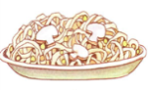

_____________________ __________________________

3. want / I / chips 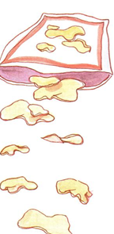 4. That’s / pillow / my 

 