Hoa Loi Primary School
Student’s name: …………………………….. ; Class: 3…..
ĐỀ ÔN TIẾNG ANH LỚP 3 ĐỀ 2 ( TỪ 30/3 – 3/4/2020 )
1. Look and write
Yes, it is. | No, it isn’t.

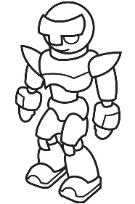 | 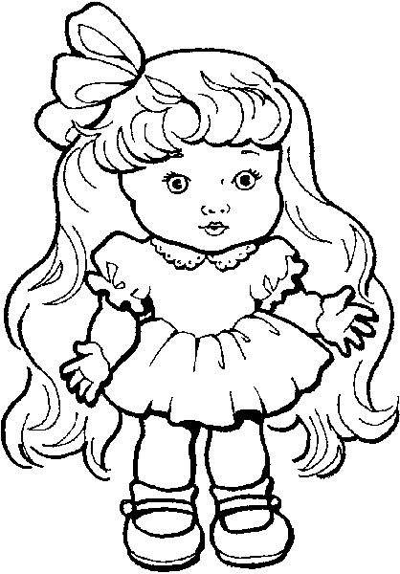 | 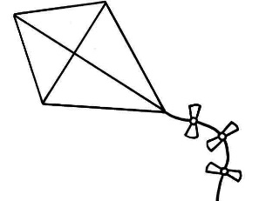
- Is it a bike ? | - Is it a doll ? | - Is it a kite ?
…………………………… | …………………………… | ……………………………
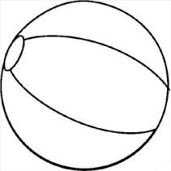 |  | 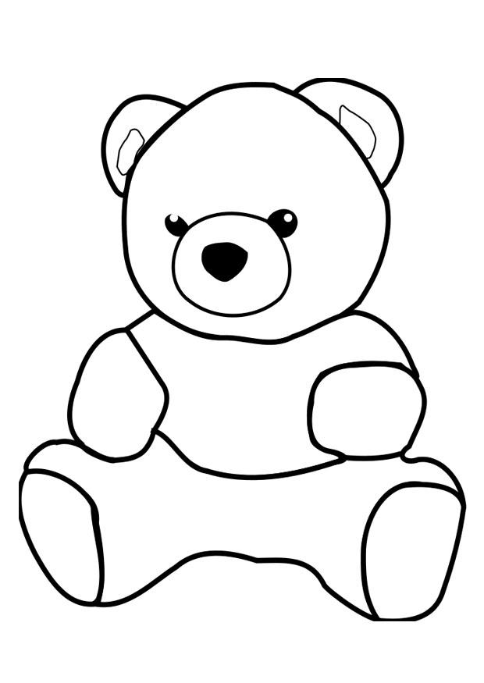
- Is it a robot ? | - Is it a car ? | - Is it a teddy bear ?
…………………………… | …………………………… | ……………………………

2. Circle the odd one out
- pen | - teddy bear | - doll | - ball
- robot | - plane | - car | - pencil
- five | - yellow | - train | - blue
- pencil | - bag | - book | - brown
- is | - am | - are | - What
- They | - his | - He | - She
- ten | - three | - nine | - black

3. Answer the questions about you
a) What is your name ?
……………………………………………………………………………………………..
b) How old are you ?
……………………………………………………………………………………………..
c) How are you today ?
……………………………………………………………………………………………..
d) What is your favorite color ?
……………………………………………………………………………………………..
e) What is your favorite toy ?
……………………………………………………………………………………………..

