Hoa Loi Primary School
Student’s name: ……………………… ; Class 2….

ĐỀ ÔN TIẾNG ANH LỚP 2 ĐỀ 1 TỪ 30//3 – 3/4/2020

A.Write ( viết )

run, slide, mommy, swing, daddy, farmer, run, police officer, noodles, doctor
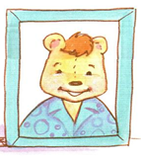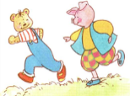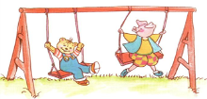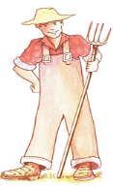
________ _________ _______ _________ ________ _________

B. READING.
Circle the correct picture (Khoanh tròn bức tranh đúng)
1.She’s a police officer
2.I like noodles 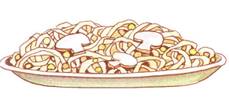
3.It’s snowing
5.I don’t like fish 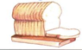

C. WRITING.
Part 1. Fill in the blank (Điền vào ô trống với từ đúng với tranh cho sẵn) :
1.Ok.Let’s __________
2.Ok.Let’s ____________

3. I like ________. 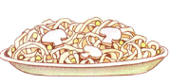
4.I don’t like _______.
5.He’s my _________. 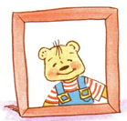

Part 2.Reorder (sắp xếp lại các câu sau theo trật tự đúng) :

1.meat / I / like 2. like / chicken / I / don’t
_________________ ______________________
3.chicken. / Have / some 4. some / soup. / Have
_________________________ ___________________________
5.pillow. / my / That’s 6.That’s / bear . / my
__________________ _____________________
7.want / I / candy. 8.ice- cream. / want / I
___________________ _______________________

