Hoa Loi Primary School
Student’s name: ……………………… ; Class 2….

ĐỀ ÔN TIẾNG ANH LỚP 2 ĐỀ 2 TỪ 30//3 – 3/4/2020

A.Write ( viết )
chicken, soup, mommy, chips, meat, run, candy, noodles
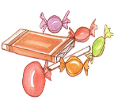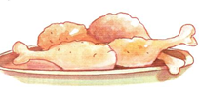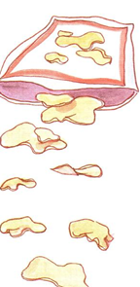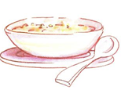
_______ ________ ________ ______
B. READING.
Part 1. Circle the correct picture (Khoanh tròn bức tranh đúng)
1.He’s a farmer 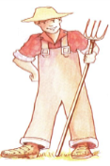 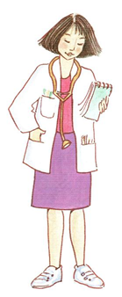
2.I like meat 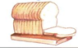
3.It’s raining 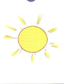 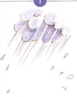 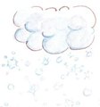
4.I want noodles 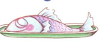 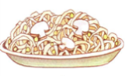
5. He’s my daddy 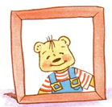 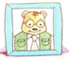

Part 2. Match ( nối các câu sau ) :
1. farmer A. 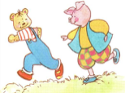
2.blanket B . 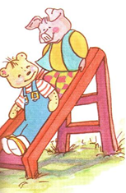
3. slide C. 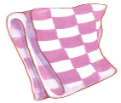
4.run D.

1.____,2_____,3_______,4______.

C. WRITING.
Reorder (sắp xếp lại các câu sau theo trật tự đúng) :

1.up ! / It’s / Hurry / raining. 2. like / candy / I / don’t
_______________________ _______________________
3. It’s / my / No ! / bear. 4.It’s / my / No ! / pillow
_________________________ ___________________________
5.chips. / want / I 6.Have / chicken./ some
__________________ _____________________

