School: Hoa Loi Primary School
Name:…………………………………. Class: 3…..

ĐỀ ÔN TẬP TIẾNG ANH LỚP 3 ĐỀ 2 ( từ 23.3 đến 27.3.2020)

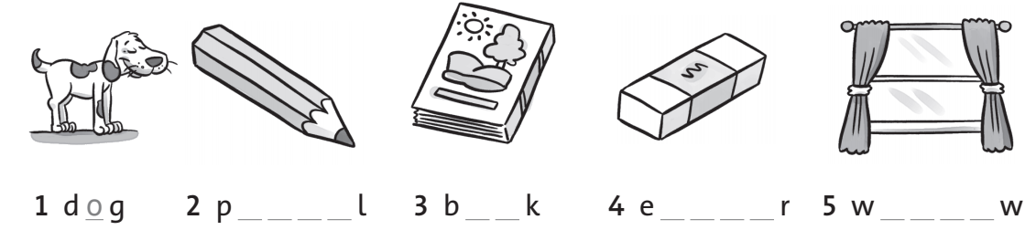
I. Complete the words.

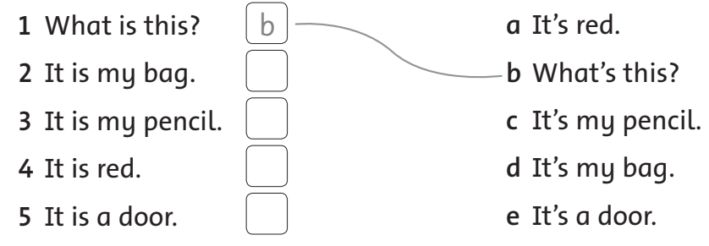
II. Match.
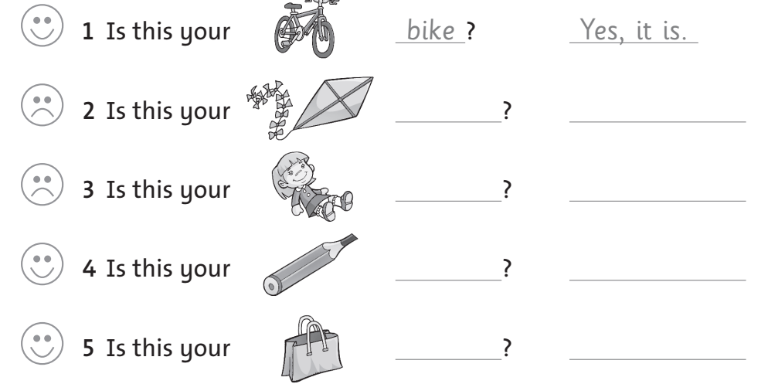
III. Look and write. (Yes, it is. / No, it isn’t. )

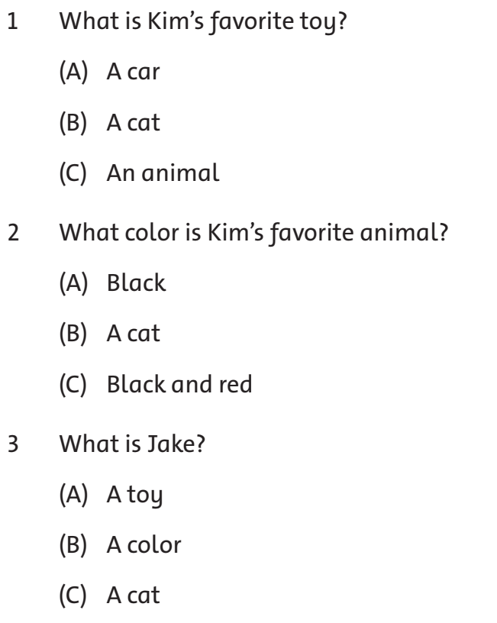
IV. Read and answer the questions. Circle A, B or C.

V. Look and write.
