Hoa Loi Primary School

Student’s name:……………………….

Class : …………

**DE CUONG ON TAP MON TIENG ANH KHOI 2 ( Đề 1 )**

**I.Write ( viết ) 2m**

|  |
| --- |
| mommy, swing, daddy, soup, run, slide |

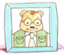 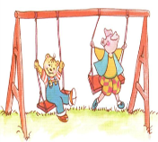 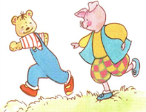 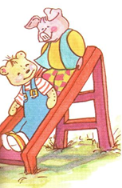 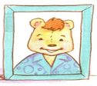 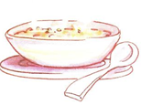

**_______ ________ ________ ________ ______ _______**

**II. Check (đánh dấu vào ô đúng)**

1.  🗆sky 5.  🗆 bread 9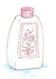🗆towel

🗆moon 🗆 fish 🗆 shampoo

2.  🗆 meat 6.  🗆 soup 10.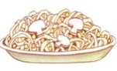 🗆noodles

🗆 noodles 🗆 rice 🗆soup

3🗆 sky 7.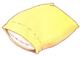 🗆pillow 11.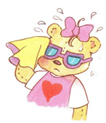 🗆I’m wet

🗆 stars 🗆towel 🗆I’m hot

4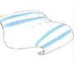🗆towel 8.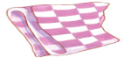 🗆bear 12.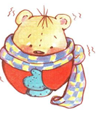 🗆I’m cold

🗆 pillow 🗆blanket 🗆I’m wet

**III. Complete the conversation (hoàn tất bài hội thoại sau)**

**1.**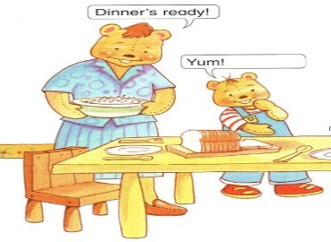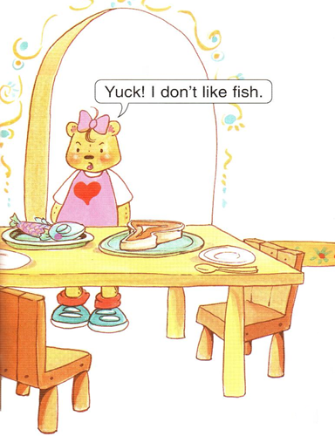

A.Yum ! I like fish

B. Yum ! I like meat

C. Yum ! I like bread

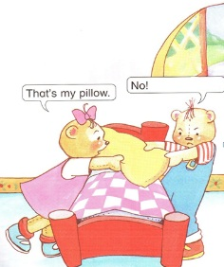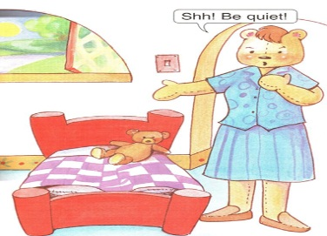

2. A.It’s my bear

B.It’s my blanket

C.It’s my pillow

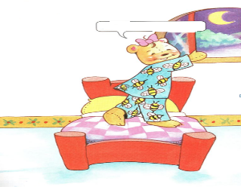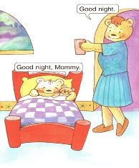

3.A.Look at the sky

B.Look at the stars

C.Look at the moon

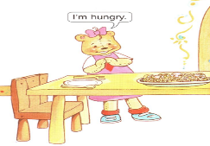 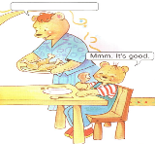

4. A.Have some noodles

B.Have some chicken

C.Have some soup

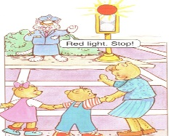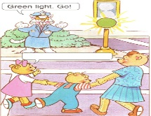

**IV Match ( nối các câu sau )**

1. police officer 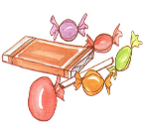

2.ice-cream 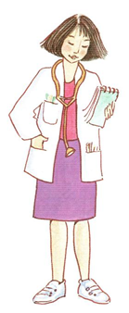

3. doctor 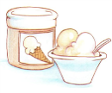

4.candy 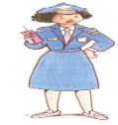

5. bear 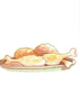

6. chicken 