Hoa Loi Primary School
Student’s name: …………………………….. ; Class: 5…..
ĐỀ ÔN TIẾNG ANH LỚP 5 ĐỀ 1 ( TỪ 30/3 – 3/4/2020 )
1.Complete these sentences with the verbs in brackets. Use the Present continuous
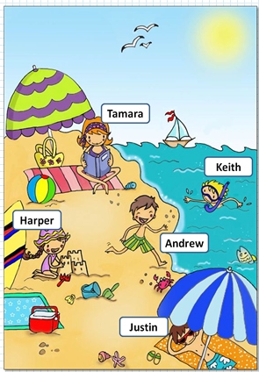 | 1.It’s summer time and the sun ________________(shine) today.  2.There are three birds _______________ (fly ) in the blue sky and the boat________________(sail) in the sea.  3.Justin ________________(lie) on a towel .He __________  (relax). He _______________ (wear) sunglasses at the moment.  4. Harper __________(wear )a hat.____________(she/build) a sandcastle now ?Yes, she is. She _________(smile)  5.Andrew _________ (not play ).He _______________(run) to the water.  He __________________(laugh)!  6.Tamara _____________(sit) on her towel. She ___________ (read) a very interesting book.  7.Keith ________________ (snorkel ) today .Now he __________(swim)  to the shore.  8.These people __________________ (not have) lunch right now.  9. _______________(they/enjoy) at the beach ? Yes , they are.
2.Read and match
- What is she doing ? | - He is making a sandcastle.
- Are you reading a book ? | - She is swimming.
- What is he doing ? | - Yes , I am.
- What are they doing ? | - Yes , they are.
- Are they windsurfing? | - They are surfing.
- Is she sailing ? | - No, he isn’t.
- Is he snorkeling? | - Yes , she is.

3.Read and circle
a. My father ______________ phoning his friend. He’s reading a book.
- am not | - isn’t | - aren’t
b.________________ the dogs swimming ? No , they aren’t .
- Am | - Is | - Are
c. I am _____________ my homework now.
- doing | - do | - does
d. Are you riding a bike now ? Yes , I _____________ .
- am not | - is | - am
e. Is she painting now ? No , she _______________.
- isn’t | - is | - aren’t
f. Are you swimming ? Yes , I _____________.
- am | - isn’t | - aren’t
g. What _______ she doing ? She is windsurfing.
- am | - is | - aren’t
h. Are they making a sandcastle? Yes , they _____________.
- am | - is | - are
i. Is she flying a kite ? No , she __________.
- am not | - isn’t | - aren’t
j . Are they kayaking? No , they __________.
- isn’t | - is | - aren’t
k._________ Lisa and Lily playing chess ? Yes , they are.
- Are | - Is | - Am
l. What are they doing ? They ___________ playing volleyball.
- are | - is | - am

