Hoa Loi Primary School  Class: ………………  Name:……………………………………….. | Review

ĐỀ ÔN TIẾNG ANH LỚP 4 ĐỀ 1 (TỪ 30/3 – 03/ 04/ 2020)

- Look and write.

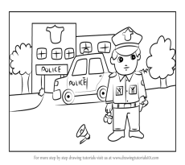 | 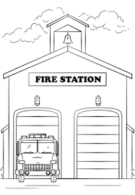 | 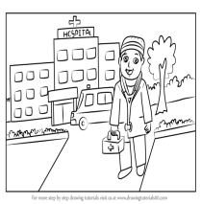
P……………. | F…………… | H………….. | A…………. | S……………..

- Read and circle.
- My name is Khoi. I like / likes playing football.
- I doesn’t/ don’t like chocolate so much.
- This is my dad. He like/ likes reading book.
- My mom like/likes cakes and nuts.
- This is my sister, Linda. She doesn’t/ don’t like candy.
- I like/ likes balloons.
- Nhi like/ likes present.
- Billy don’t/ doesn’t like trains and cars.
- Trung like/ likes ice cream.
- Hoa don’t/ doesn’t like mangoes.
- I likes/ likes apples.
- My teacher like/ likes taking photos.
- I doesn’t/ don’t like card.
- He likes/ like milkshake and pizza.

- Read and write. True or False.
Hi, my name’s Bach Tuyet. I go to Hoa Loi Priamy School. I am ten years old. I miss my class so much. I am in class 4A3. My classroom is very big and fresh. There are 25 boys and 20 girls in my class. Our teacher is Mrs. Diep. She is 40 years old. There are lots of pictures and posters on the wall. I love my school!

- Her name is Tuyet Bach. | False
- She is ten years old.
- He misses his school so much.
- She is in class 3A4.
- She doesn’t love her school.
- Her classroom is small and fresh.
- There are 20 boys in her class.
- There are 25 girls in her class.
- Her teacher name is Mrs. Lien
- Mrs. Diep is 35 years old.

