Hoa Loi Primary School  Class: ………………  Name:……………………………………….. | Review

ĐỀ ÔN TIẾNG ANH LỚP 4 ĐỀ 2 (TỪ 30/3 – 03/ 04/ 2020)

- Look and write.
 | 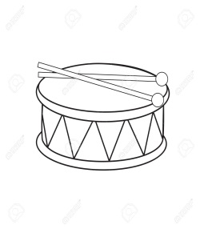 | 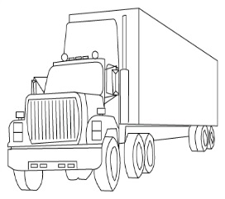 | 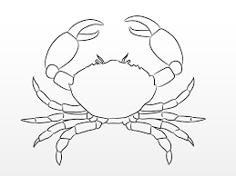

- Read, choose, and circle the correct answer.
There’s
1……….( / there are) a doll on the rug.
2. ……..( Those are / That is) a new table.
3. ……..she…..chicken? Yes, she does. ( Do, have / Does, have )
4……….do we have on Monday? We have English. ( What / When)
5. What time…..it? ( is / are )
- Read and write.
behind/ Yes/ Rosy/ Tim/ have/ under/

Mom: Do you ___________(1) a milkshake, Rosy?
Rosy: _______(2), I do
Mom: Where’s _____________(3)?
Rosy: He’s ____________(4) the tree.

- Reorder the sentence.

1.you/have/Do/?/pizza
2. he/ does/ sandwich/?/ have
3. and/ he / have/ doesn’t/ cake.
4. noodles/?/ Do/ you / have
5. she/ chicken /has/ lunch/ for.
6. I / fish/ and/ have/ rice/dinner/for.
7.windows/ how/there/?/are/many
8.your/class/name/what/?/’s
9. Do/like/you/grapes/?
10.there/are/oranges/mangoes/and.
11.bananas/have/you/?Do
12.Do / you/ have/ pears?

