Hoa Loi Primary School  Class: ………………  Name:……………………………………….. | Review

ĐỀ ÔN TIẾNG ANH LỚP 4 ĐỀ 1 ( TỪ 23 – 27/3/2020 )

- Write.
Go/ have

- Go to school.
- ............ dinner.
- ............ breakfast.
- ............ home.
- Look and write.
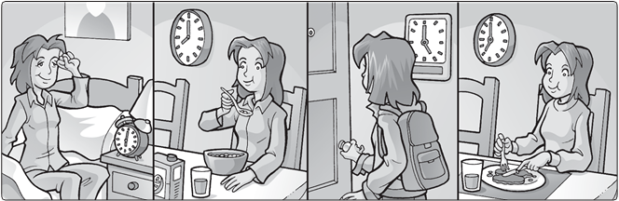
1. She goes home at five o’clock .

2 She at .
3 She at .
4 She at .

Complete.

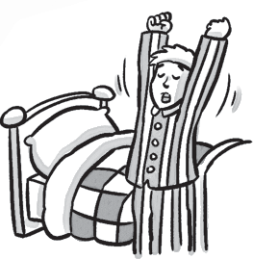
- I get up at seven o’clock.
3
1
2
- My dad at six o’clock.
- Sarah to school at nine o’clock.
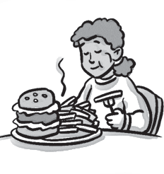
- Sarah dinner at seven o’clock.
5
6
4
- I home at four o’clock.
- I dinner at six o’clock.

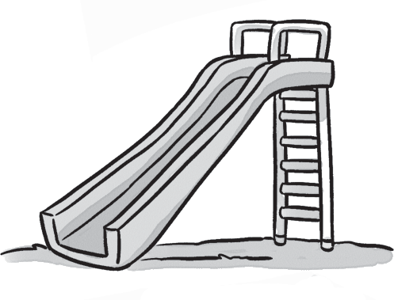

Complete the words.
cloud __ ide

ar __oves

ow __ ile

