School: Hoa Loi Primary School
Name:…………………………………. Class: 3…..

ĐỀ ÔN TẬP TIẾNG ANH LỚP 3 ĐỀ 1 ( từ 23.3 đến 27.3.2020)

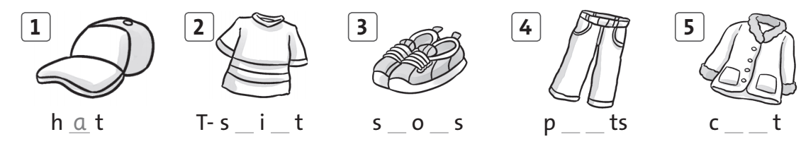
I. Complete the words.

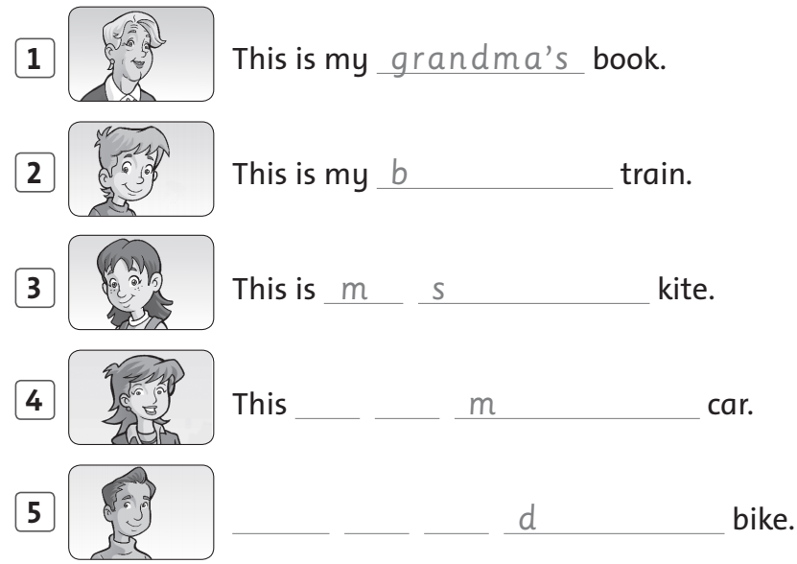
II. Look and write.

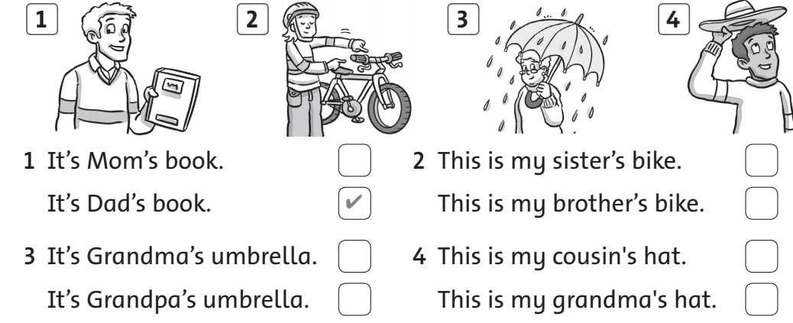
III. Check () the correct sentence.
IV. Read and write the name.
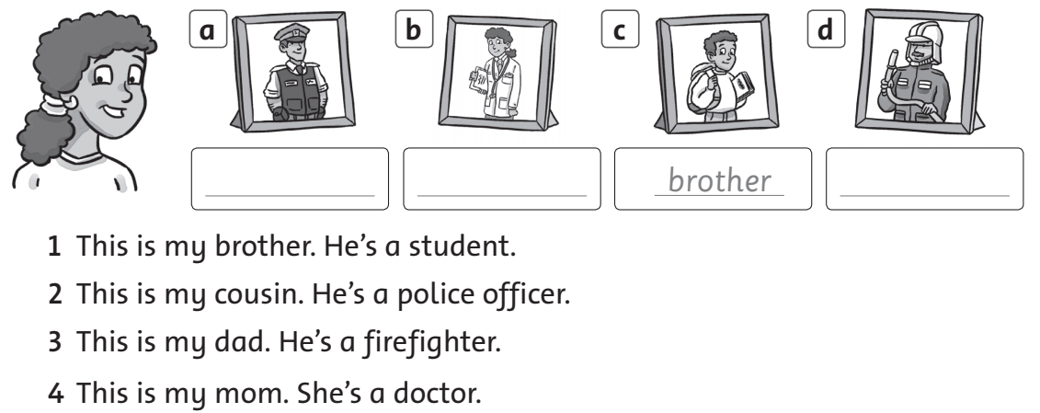
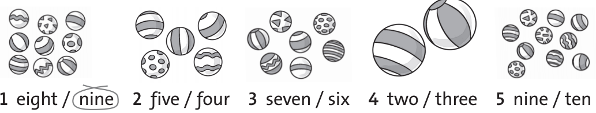
V. How many? Count and circle.

VI. Look and write.
