Hoa Loi Primary School
Student’s name : …………………………… ; Class:5….
ĐỀ ÔN TIẾNG ANH LỚP 5 ĐỀ 2 ( TỪ 23 – 27/3/2020 )
1.Look and write
Yes, it is  No , it isn’t. | Yes, they are.  No, they aren’t.

Is the frog playing the guitar ? | Is the parrot reading a book ? | Are the birds singing ?
…………………………………… | ……………………………… | …………………………………
Is the rat sleeping ? | Is the monkey fishing ? | Is the owl writing ?
…………………………………… | ……………………………… | …………………………………
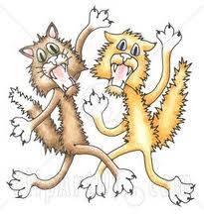
Are the cats fighting? | Is the bear playing volleyball ? | Is the penguin surfing ?
…………………………………… | ……………………………… | ………………………………
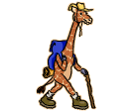

Is the giraffe walking ? | Is the dog running ? | Is the squirrel kayaking ?
…………………………………… | ………………………………… | …………………………………

2.Look , read and write.
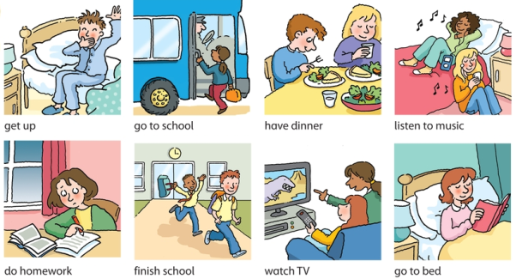
- I get up at six o’clock.
- Sally _____________ up at seven o’clock.
- I ___________ my homework in the morning.
- Sally _________ her homework in the evening.
- I ___________ school by bus.
- Sally ___________ school by car.
- We ___________ school at three o’clock.
- We ______________ dinner at 6.30 p.m.
- I _________________TV in the evening.
- Sally _______________ to music.
- I _________________________ to bed at nine o’clock.
- Sally_________________________ to bed at ten o’clock.

