Hoa Loi Primary School
Student’s name: ……………………… ; Class 2….
ĐỀ ÔN TIẾNG ANH LỚP 2 ĐỀ 1 ( TỪ 23 – 27/3/2020 )

A.Write ( viết )
run, mommy, swing, daddy, meat, run, slide, noodles
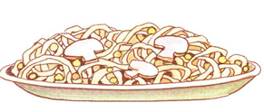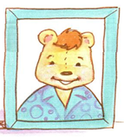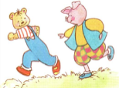
________ _________ _______ _________
B. READING.
Part 1. Circle the correct picture (Khoanh tròn bức tranh đúng)
1.She’s a doctor
2.I like meat
3.It’s sunny
4.I don’t like fish 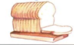 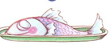
Part 2. Match ( nối các câu sau ) :
1.sky A.
2.towel B.
3.fish C.
4.meat D. 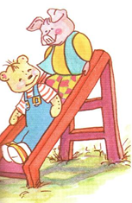
5.slide E.
6.run F.

1.____,2_____,3_______,4______,5_______,6________.

C. WRITING.
Reorder (sắp xếp lại các câu sau theo trật tự đúng) :
1.rice / I / like 2. like / soup / I / don’t 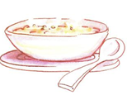
_________________ _______________________________
3.sister. / She’s / my 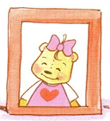 4.He’s / brother./ my 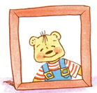
_________________________ _________________________________
5.farmer / a / He’s 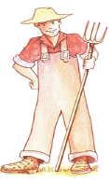 6.She’s / police officer./ a
__________________ _____________________

