Hoa Loi Primary School
Student’s name: …………………………….. ; Class: 5…..
ĐỀ ÔN TIẾNG ANH LỚP 5 ĐỀ 1 ( TỪ 23 – 27/3/2020 )
1.Look and write
 | 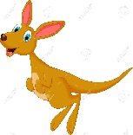 | 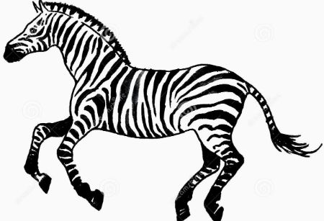
What is the monkey doing ? | What is the kangaroo doing ? | What is the zebra doing ?
…………………………………. | ………………………………… | …………………………………
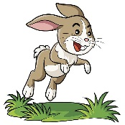 | 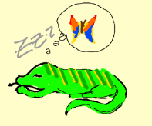
What is the rabbit doing ? | What is the lizard doing ? | What is the fish doing ?
………………………………… | ………………………………… | …………………………………
 | 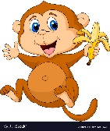 | 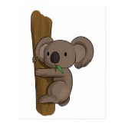
What is the parrot doing ? | What is the monkey doing ? | What is the koala doing ?
………………………………… | ………………………………… | …………………………………

2. Read and circle the correct words.
- He gets/ get up early. | - We catch/catches the bus. | - Tony have/has breakfast with his family.
- Lisa brushes/brush her teeth every morning. | - I have /has shower every day. | - Do/does you go to school everyday ?
- She have /has breakfast every morning. | - Do/Does they catch the bus every morning ? | - They go /goes to school every day.
- Anna don’t/doesn’t catch the bus. | - What time do/does Toby go to school? | - Do/Does they brush their teeth at night ?
- He don’t/doesn’t walk to school. | - My sister get/gets up at six o’clock. | - Do/Does she have a shower at night ?

3. Put the words in the correct order to make sentences
 |  | 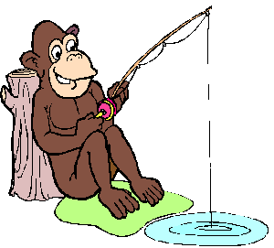
flying/The /parrot/is | squirrel/The/is/kayaking. | fishing/The /monkey/is
………………………………… | ………………………………… | …………………………………
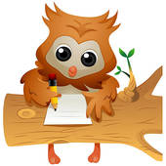 | 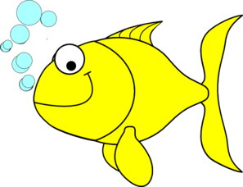 | 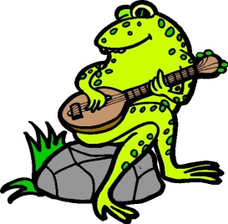
writing/The/owl/is | swimming./The/fish/is | playing/The/guitar./is/frog/the
………………………………… | ………………………………… | …………………………………
 |  | 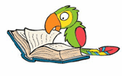
lizard/The/is/slepping./ | The/climbing/are/koalas | The /reading/is/ a /book./ parrot
………………………………… | ………………………………… | …………………………………
 |  | 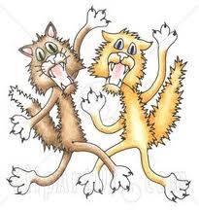
jumping/The/kangaroo./is | The/flying./birds/are/ | cats/The/are/ fighting
………………………………… | ………………………………… | …………………………………

